

**ICPEP SE SSU**

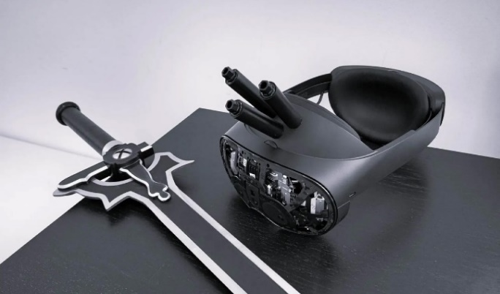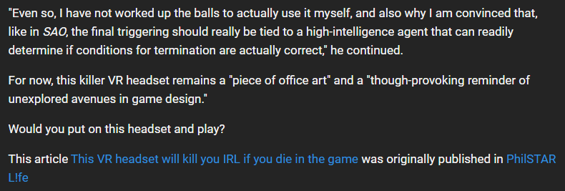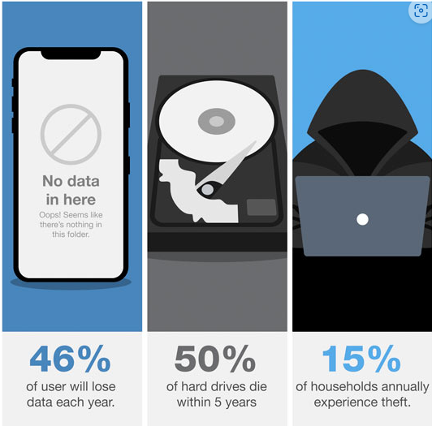

First, you have to dig through all those folders across ALL your devices… then organize all your photos and videos… and then you have to go through each file and figure out which ones you’re going to back up, removing the duplicates you’ve already backed up in the past. You can easily spend hundreds of hours going through everything!

We’d all rather spend our free time doing just about anything else. But get this: 140,000 hard drives crash EVERY WEEK in the United States alone…

And as a result, about 46% of internet users lose their files every year.

*This website is an advertising market place for companies who provide consumers products and services. This website is an advertisement and not a news publication. All persons depicted on this site are models. The owner does not recommend or endorse any specific company. Terms, conditions and exclusions may apply.*



FOLLOW US OUT THERE



@icpep.se@ssu.edu.ph

*Search for an article*



**Institute of Computer Engineers of the Philippines Headlines**

**“ WE INNOVATE, WE BUILD, WE SERVE ”**



**I Tested A Device That Saves You Hours By Automatically Finding & Backing Up Your Photos And Videos With ONE Click… But I Never Expected This!**

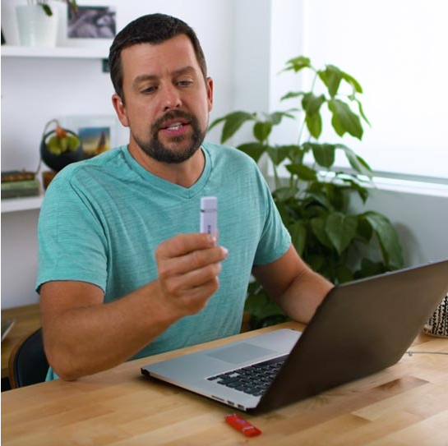

***Do you have a lot of photos and videos stored on your computer and/or phone? Read this article closely… it could prevent a tragedy!***